**Project 02_04_03**

In this Project we will build an All-in-One Sticky form applications to test our knowledge of the unit. Be sure to document all of your code to indicate your understanding.

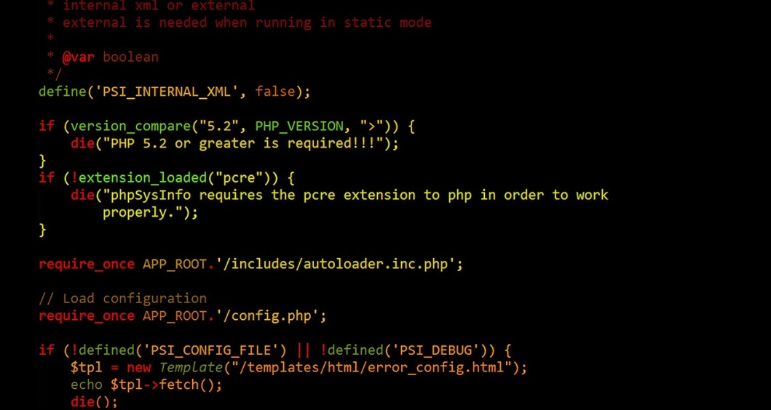 

In this Project, you will create an All-in-One Sticky form that solves the common “two trains are moving toward each other” word problem. Use a PHP document named **TwoTrains.php** to receive and process the form.

The form should have 3 inputs, all must be numbers greater than 0:

1. ***$speedA*** – the speed of Train A
2. ***$speedB*** – the speed of Train B
3. ***$distance*** – the distance between the 2 trains

You will need the following equations:

1. ***$distanceA = (($speedA / $speedB) * $distance) /   
    (1 + ($speedA / $speedB));***
2. ***$distanceB = $distance - $distanceA;***
3. ***$timeA = $distanceA / $speedA;***
4. ***$timeB = $distanceB / $speedB;***

Compute for $timeA and $timeB, which should be equal, and are how long . Trains A and B traveled, respectively. Trap and report all errors, including speed or distance <= 0.